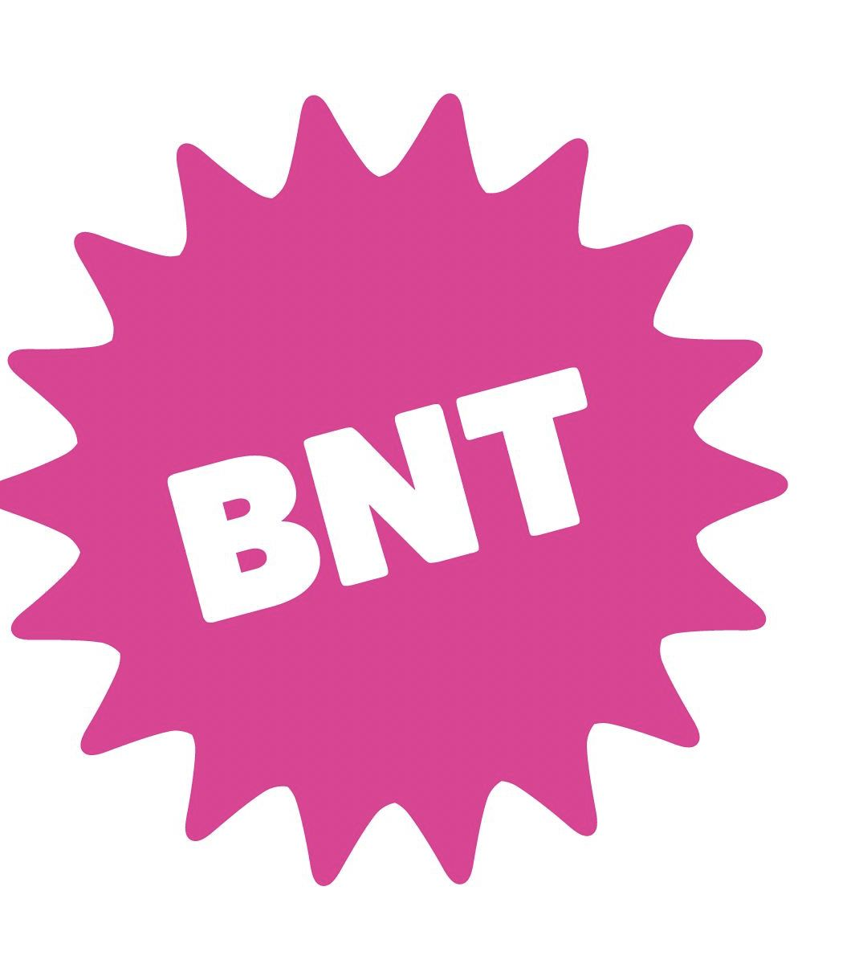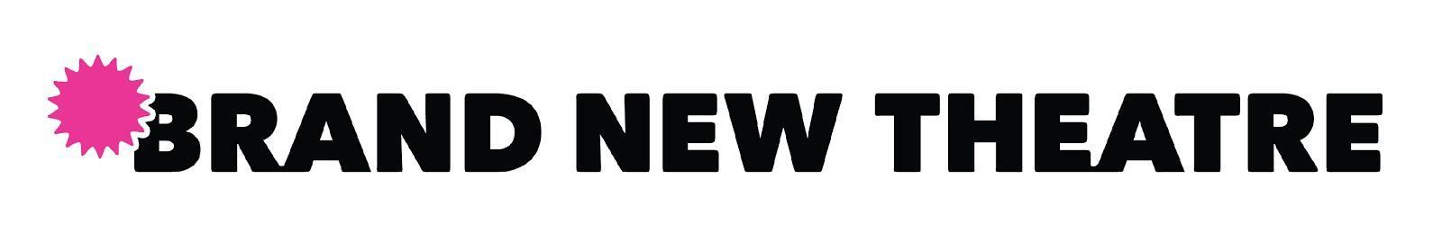
Full-Length Writing Workshop 2019-2020 Application
Starting in 2018, Brand New Theatre has offered a playwriting workshop for those in search of a strong and supportive critical literary opinion from their peers. ​Each year, we accept a number of playwriting submissions that are reviewed by our Literary Board for editing and feedback. In preparation for our Spring full-length, we are expanding our workshop and hosting two rounds, in November and December, in hopes of promoting writing among students looking to produce their works with BNT or other theatre groups.
Applicants will be able to submit a TOTAL of two (2) submissions PER workshop. The deadline for first round of submissions is ​November 10​ 2019 @ 11:59 PM PST​. The second deadline for submissions is ​December 8​ 2019 @ 11:59PM PST​. Submissions for the first round can be unfinished, but should include, at a minimum, an outline and a few scenes. Submissions for the second round should be further along, and close to complete. Submitting to both rounds is not mandatory, and the more you send the more feedback you will receive! Submit to ​brandnewtheatre@gmail.com​ with “YOUR NAME – (ONE ACT, FULL LENGTH, CONCEPT)” in the subject line.
Submissions act as a CONTRACT between the writer and BNT to actively work together on these pieces of dramatic writing. Please do not abuse this opportunity! We are students and writers as well and want to see our combined efforts put to good use. Writers are not obligated to submit for BNT’s Full Length in the Spring after the workshops, but are HIGHLY ENCOURAGED.

One final thing: Have fun with this! We are excited to help you with your work and want to make this experience as fulfilling as possible. If you have any concerns or questions about submitting or the process, email ​brandnewtheatre@gmail.com​ and we’ll get back to you ASAP! ​____________________________________________________________________________________________________ REQUIREMENTS FOR SUBMISSION
- ROUND ONE - Deadline Nov 10
  - At least 20-30 pages of self-produced work
  - A two (2) page outline of the whole work, detailing a basic structure of plot, character, and thematic choices (can be in any format, but should give us a detailed idea of what you are trying to create and where you want to go with it)
  - Receive feedback by Nov 17
- ROUND TWO - Deadline Dec 8
  - A minimum of 50 pages of self-produced work
  - A two (2) page outline of the whole work, detailing a basic structure of plot, character, and thematic choices (can be in any format, but should give us a detailed idea of what you are trying to create and where you want to go with it)
  - Receive feedback by Dec 18
A couple of days after submitting, you will receive an email confirming that BNT will review your work if we accept your application. ​You’re welcome to reach out after you have received feedback and we encourage you to resubmit for round two after taking the edits into consideration. SUBMISSIONS FOR THE FULL-LENGTH WILL BE DUE THE FIRST WEEK OF JANUARY!
_______________________________________________________________________________________________________
(Fill out form below and attach outline and doc)
Please be as thorough as possible in your application and outline so we can provide the best feedback for YOU
Name:
Class:
Major:
Name of Submission (if any):
QUESTIONS:
- How long have you been working on this?
- What is your final goal for this work?
- Why are you submitting to us?
- Why is this work/idea special to you?
- Who are your writing influences (if any)?
- Brief Bio: Who are you? What do you do around campus or otherwise?
- How involved do you want us to be?

